City of T or C Inventory System Instruction Manual

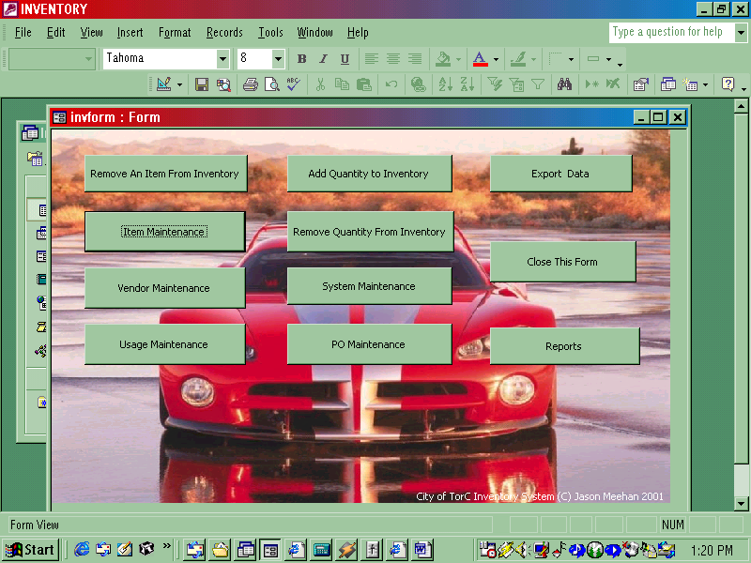

City of T or C Inventory System Copyright © 2001 by Jason Meehan
All rights reserved. No part of this manual shall be reproduced, stored in a retrieval system, or transmitted by any means, electronic, mechanical, photocopying, recording, or otherwise, without written permission from the author.
Main Menu

Remove an item from Inventory- This will delete an Item from inventory

Item maintenance- Use this to add, edit and search for items in your inventory

Vendor maintenance – This will allow you to add, delete and edit your vendors.

Usage maintenance – Use this for Edit, delete, search and print usage reports

Add quantity to inventory – Allows you to add to your usage

Remove quantity to inventory- Allows you to remove usage

System Maintenance – renumber part numbers , add to category, jobs and employee table

Po Maintenance – Po entry

Export data- Move data into excel, word and text files

Close form- Closes the program

Reports- Use this to create your reports

Remove an Item From Inventory

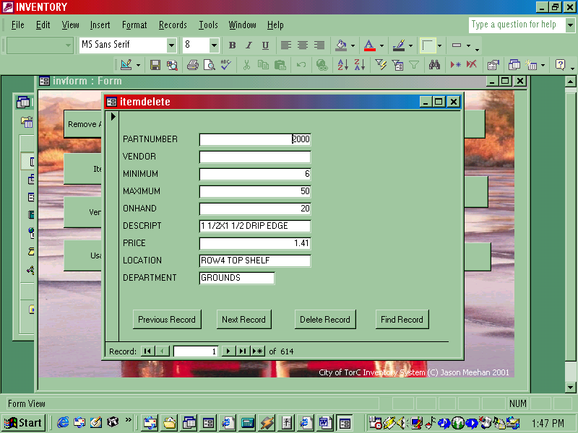

Use this to delete an item from your inventory. You can use the previous record and Next record buttons to move backward and forward through the item table. Once you have found the item you want to remove click delete record.

Find Record is used to search for an item in the item table. First click on the field that you want to search. Then click on find record.

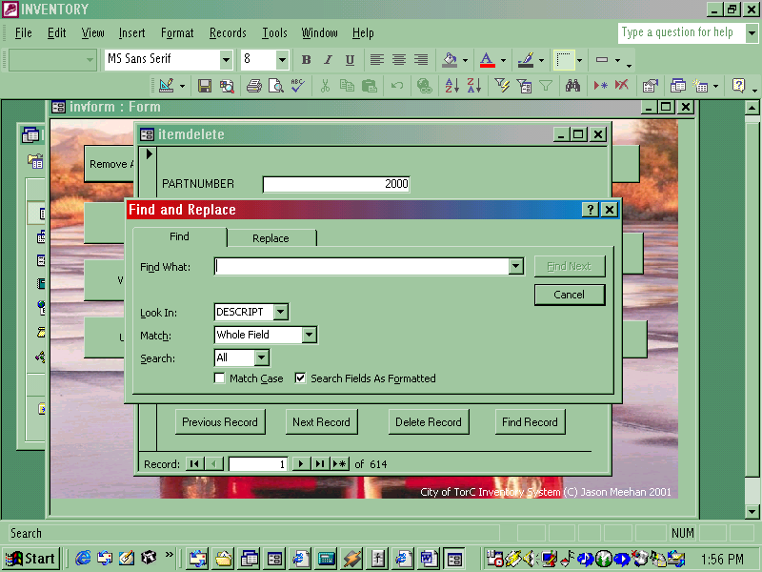

Item Maintenance

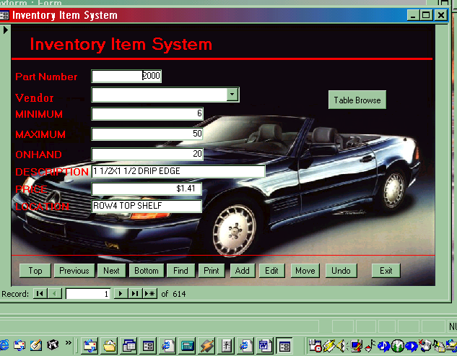

This form is used to enter and edit items in you inventory

The Top button will move you to the beginning of the item table.
The Previous button moves you backwards through the item table.
The Next button moves you forwards through the item table.
The Bottom button moves you to the last item in your table.

Searching for an Item
The Find button is used for searching in your item table. To search for an item first click on the field that you want to search.

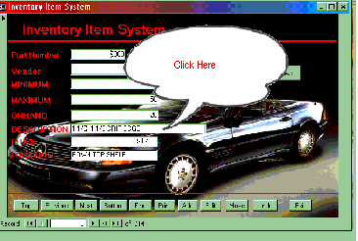

For example: if you wanted to search for an item with the description of Large Bolt , first click on the description field then click on find.

Type in the Find Box the item that your searching for.

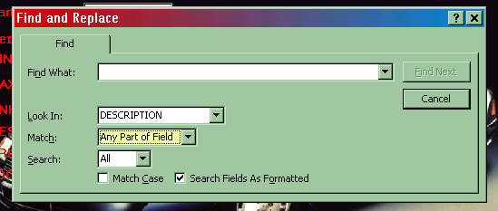

The look In box will display the field that your searching.

The Match Box gives you the option of searching Any part of Field, Whole Field or Start of Field.

Any part of Field: Select this to search for any text that is contained within the field.
For example if you where searching for the word Screw
The search would return anything with the word screw in it.
Large Screw
Big Screw 8/12

Whole Field: Returns an exact match of what your searching for. A search for the word Screw would only return
Screw

Start of Field: Returns any match at the start of the field. A search for the word Screw would return
Screw Large
Screw small

Records that you are searching for will appear in the form behind the find Box. You may need to move the find box to see your records. Clicking find in the find Box next will let you move forward to the next record with that match
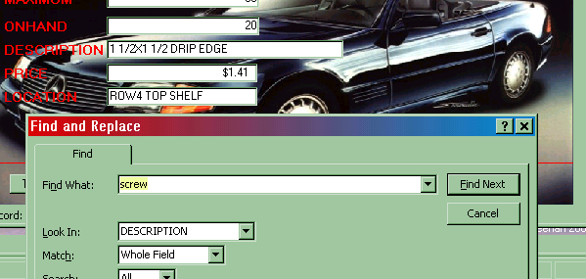

Edit Button- Use this if you need to make a change an item. Make sure the item that you want to edit is displayed on the main item maintenance form, then click edit
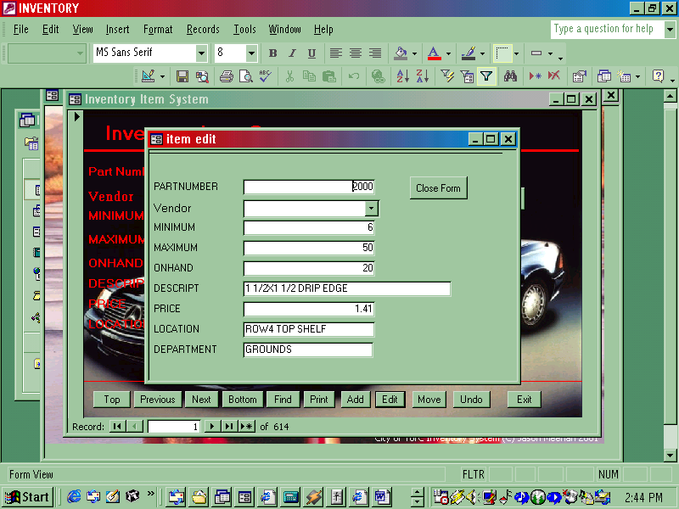

Once you are done click close. All changes are automatically saved.
You can also edit Items using table browse bottom.

Move Button- Is used to move an item to a different position in the table. For example if you wanted to move an Item with partnumber 200 to partnumber 3. The Item at partnumber 200 would be moved to partnumber 3 and the partnumber that was partnumber 3 would become partnumber 4 and all the others down the line would also be renumberd.

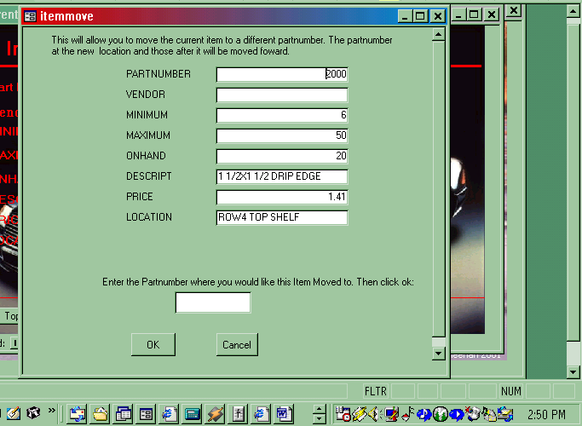

Add Quantity To Inventory

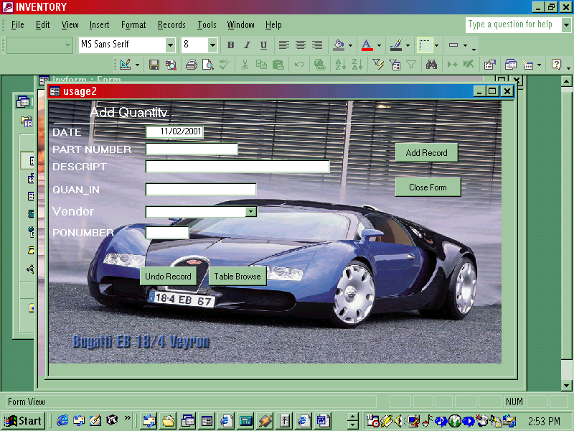
Use this To add Quantity to your inventory

Date: This field is automatically filled in with todays date. If you want you can change this.

Part number: If you happen to know the partnumber of the item your adding quantity to type it in. You can search for a partnumber by either pressing Enter of Double clicking in the part number box.

Search box

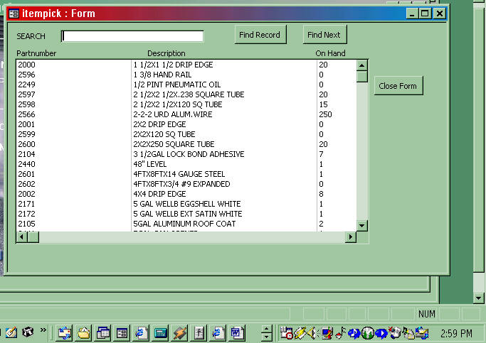

Type the Item you want to search for then click Find Record. Clicking Find Next will find the next record with that match.

Once you have found the item that you are searching for either double click it or Press enter twice to select it.

Vendor: Type in the vendor here or select it from the Drop down list.

PO: Type in Po number here

If this is the last Item click Close form. All changes will automatically be saved

If you want to add more click Add record.

Information that you previously entered will be displayed in the date box and the last item you entered will be displayed in the title bar.

Remove Quantity

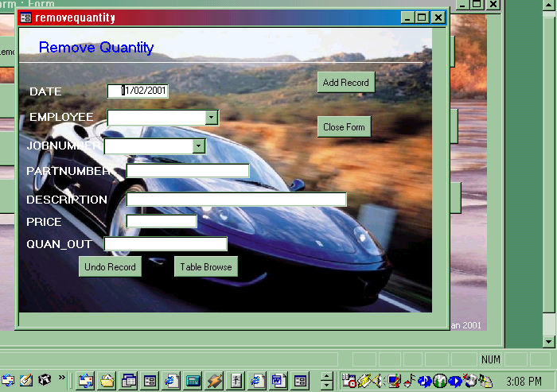

Use this form to remove quantity from your inventory

Date: This field is automatically filled in with todays date. If you want you can change this.

Employee: Enter the employee here or select it from the drop down box

Job Number : Enter the Job number hre or select it from the drop down box

Part number: If you happen to know the partnumber of the item your adding quantity to type it in. You can search for a partnumber by either pressing Enter of Double clicking in the part number box.

Search box

Type the Item you want to search for then click Find Record. Clicking Find Next will find the next record with that match.

Once you have found the item that you are searching for either double click it or Press enter twice to select it.

Price: This field is automatically filled in. Or you can type in a new price if you want

Quan out: Type Quantity out here

If this is the last Item click Close form. All changes will automatically be saved

If you want to add more click Add record.

Information that you previously entered will be displayed in the date box, employee and jobnumber box. The last item you entered will be displayed in the title bar.

